TASK 1
SQL-Based Descriptive Analytics & Reporting
iNeuBytes VIIP — Data Analyst Internship

Intern Name | Devpal Singh Anand
Regd No | INBT019627
Course ID | DAINB20626
Education | BCA · MCA Cyber Security (pursuing)
Dataset | Olist Brazilian E-Commerce (olist.db, SQLite — 96,478 orders)

1. Database Exploration
Loaded the Olist Brazilian e-commerce dataset into SQLite. Nine tables covering orders, customers, products, sellers, payments, reviews, and geolocation.
1.1 List All Tables
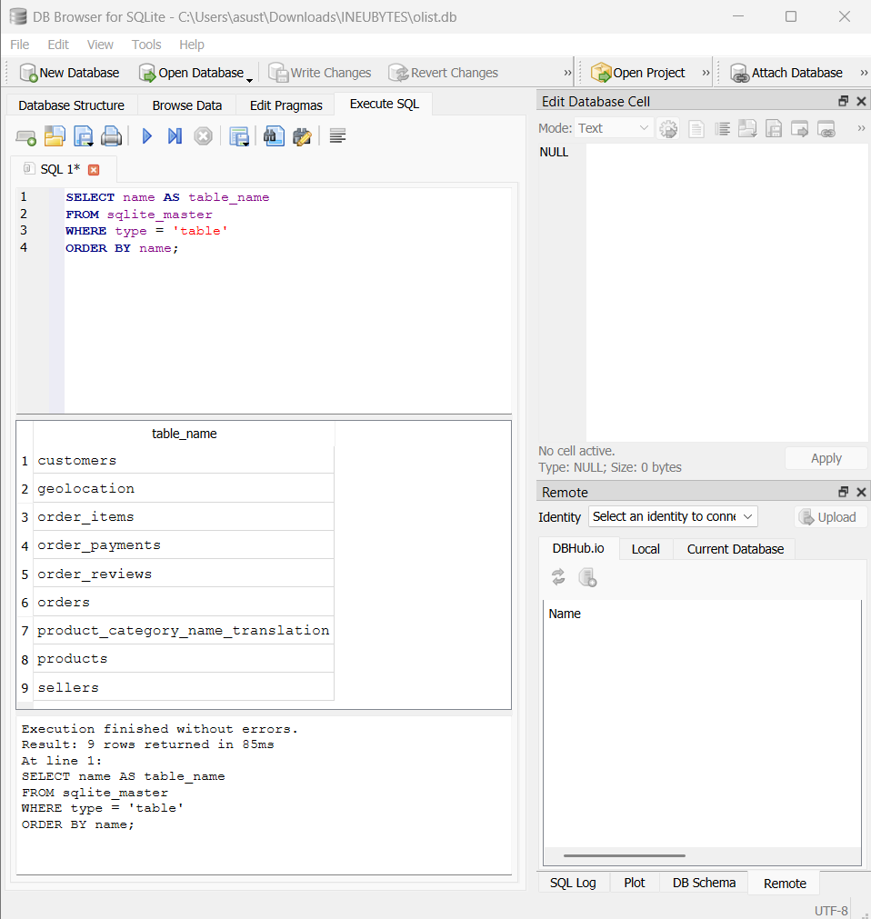
📸 Query 1.1 — Listing all tables (9 tables found)

1.2 Inspect Schema of All Tables
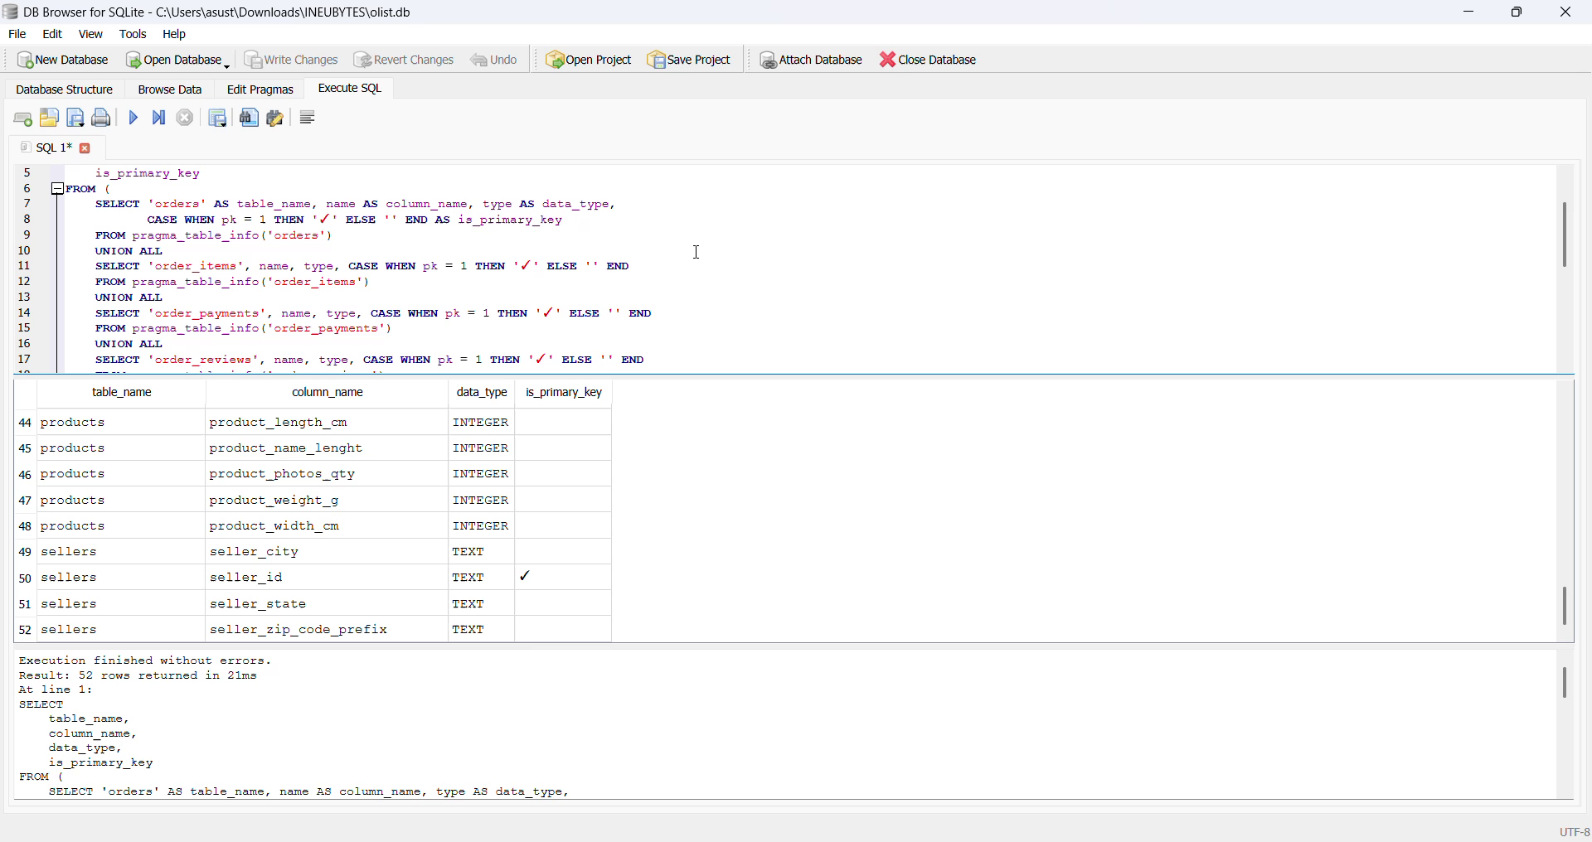
🎥 Query 1.2 — Combined schema of all 9 tables (52 columns)
▶️ Watch: https://drive.google.com/file/d/1_xusr25Q0gz2NyCpJRzDqCMflLLQ5RWV/view?usp=drive_link
1.3 Row Count for Every Table
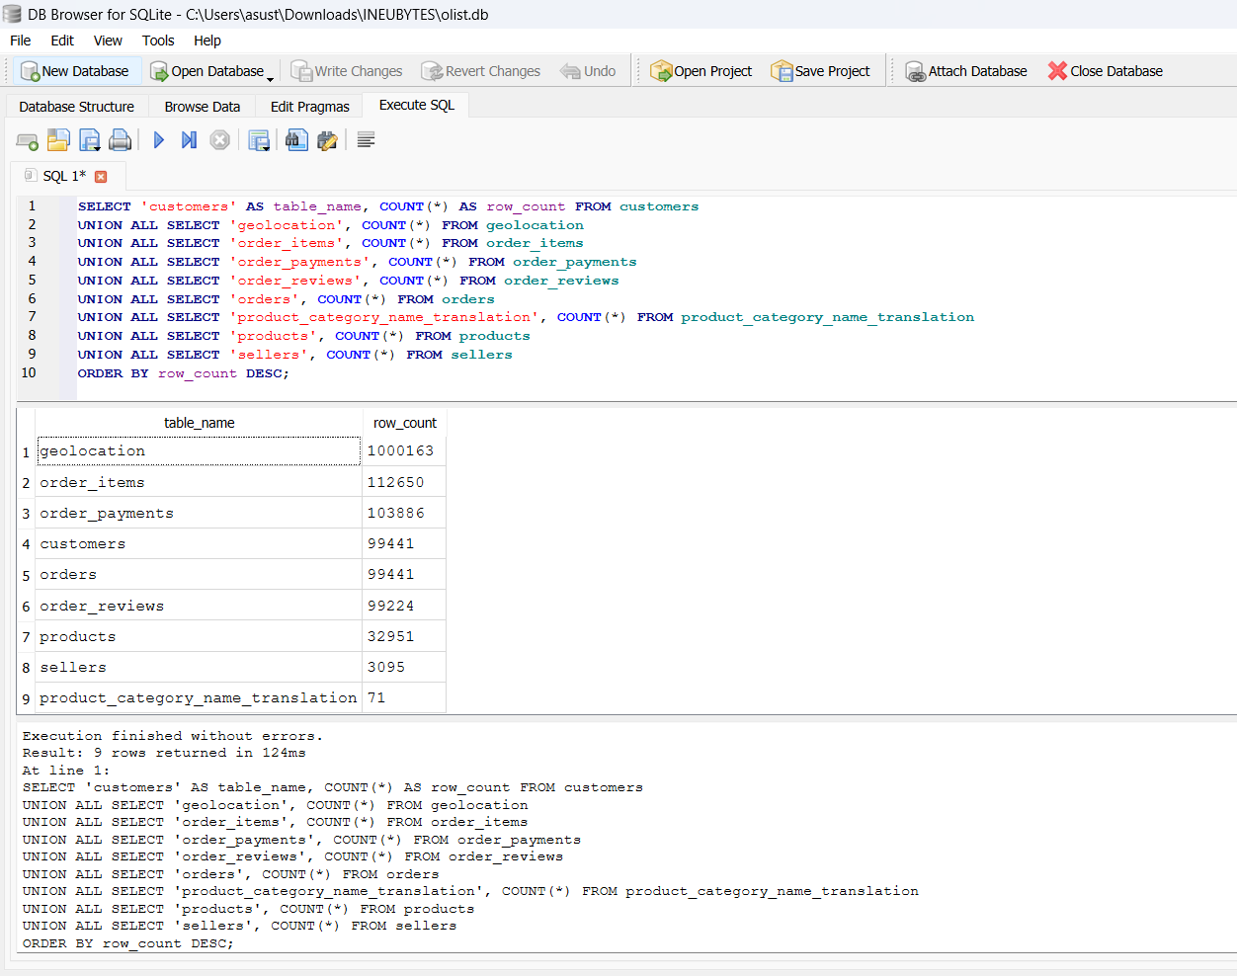
📸 Query 1.3 — Row counts for all 9 tables
1.4 Preview Sample Rows
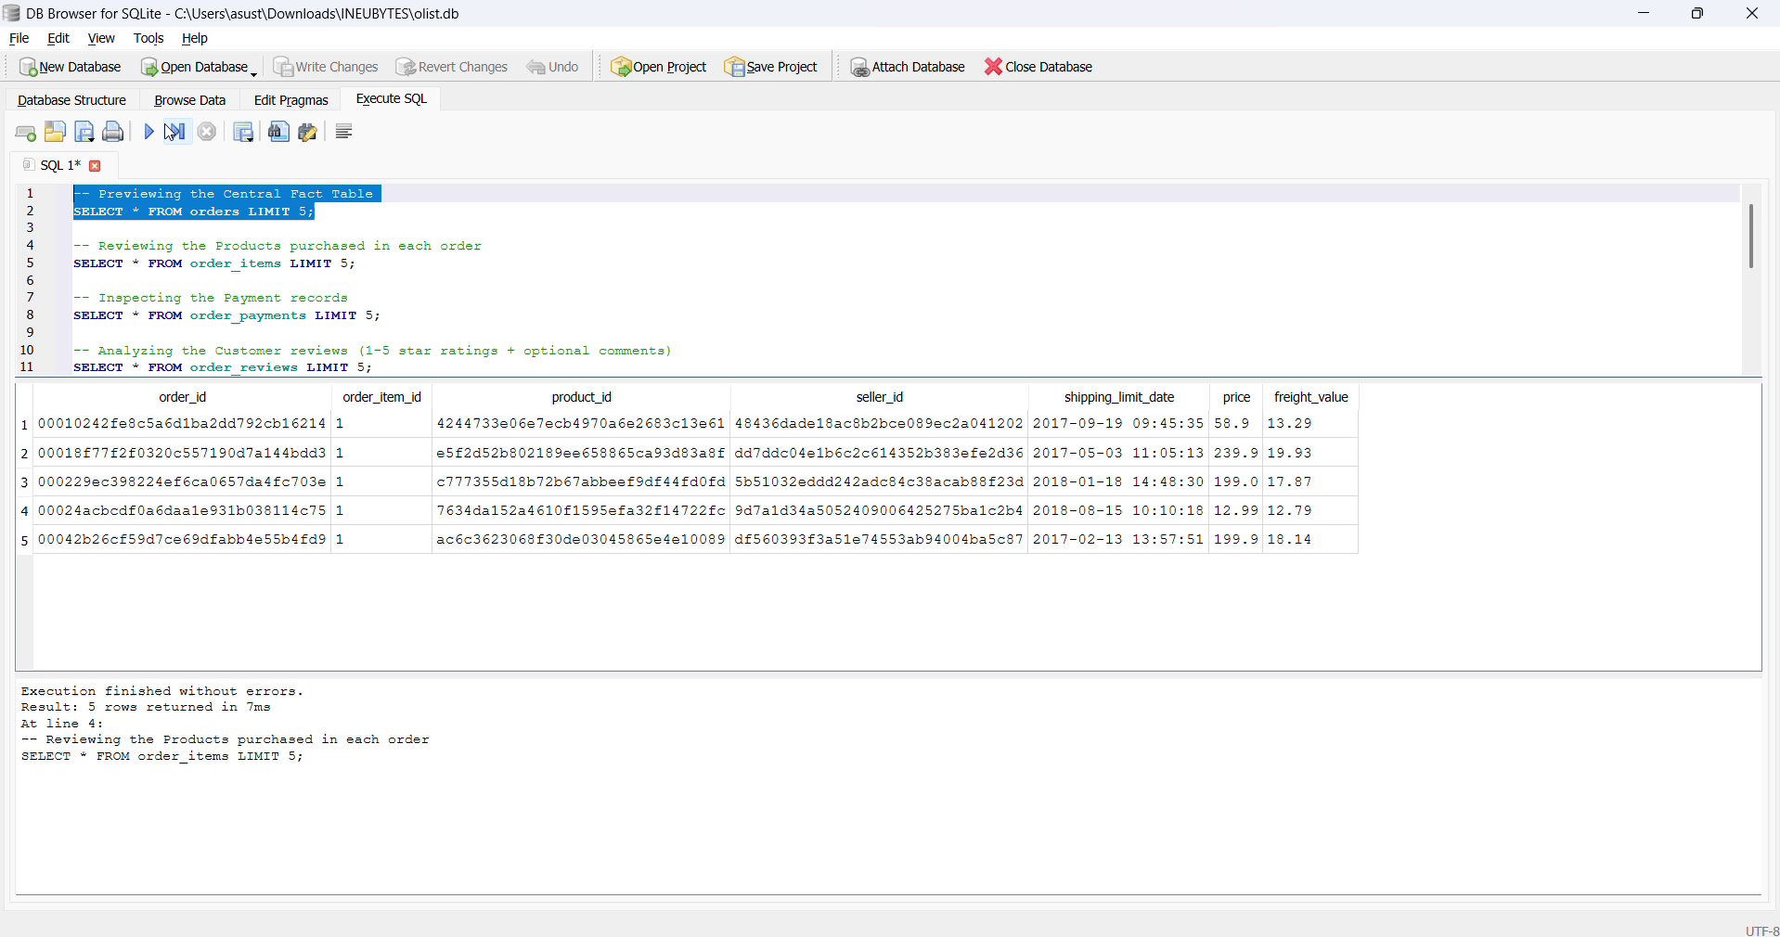
🎥 Query 1.4 — Previewing sample rows from each table
▶️ Watch: https://drive.google.com/file/d/1j0JavS2gpQsBxc0xL0ey-Cx3wxB89qL6/view?usp=drive_link

2. Data Quality Checks & Cleaning
2.1 NULL Values in Orders
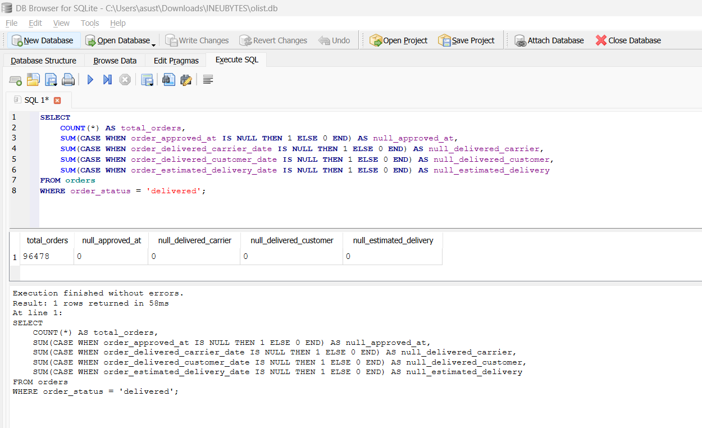
📸 2.1 NULL Values in Orders
2.2 Distribution of order_status
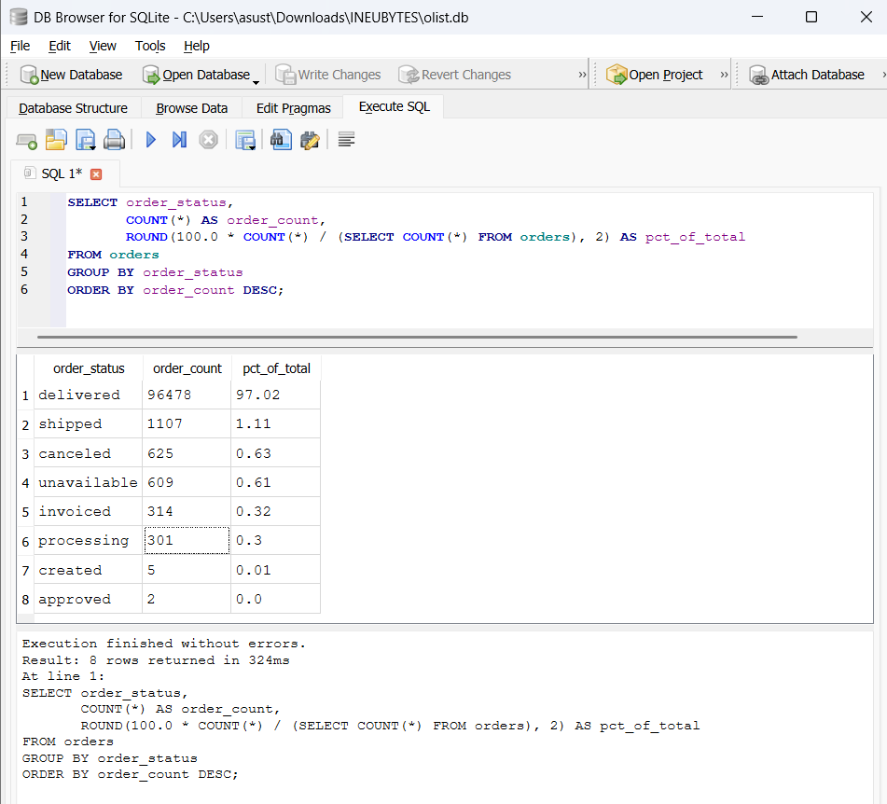
📸 2.2 Distribution of order_status
2.3 Duplicate Rows in order_items
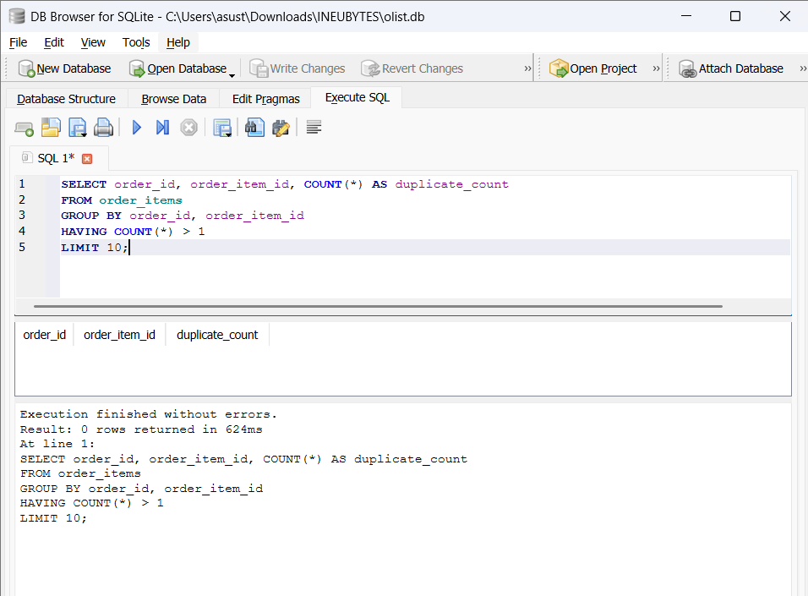
📸 2.3 Duplicate Rows in order_items
2.4 Duplicate Zip Codes in Geolocation
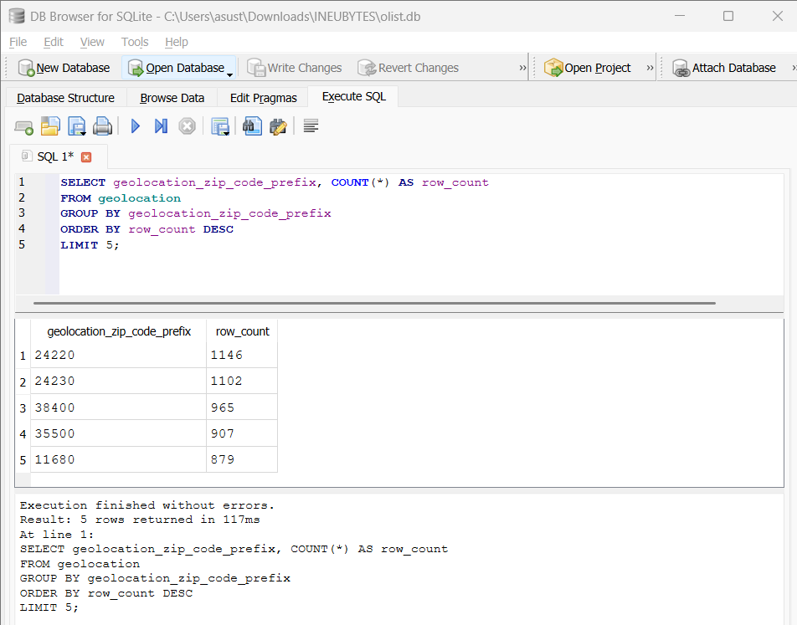
📸 2.4 Duplicate Zip Codes in Geolocation
2.5 Products with Missing Category
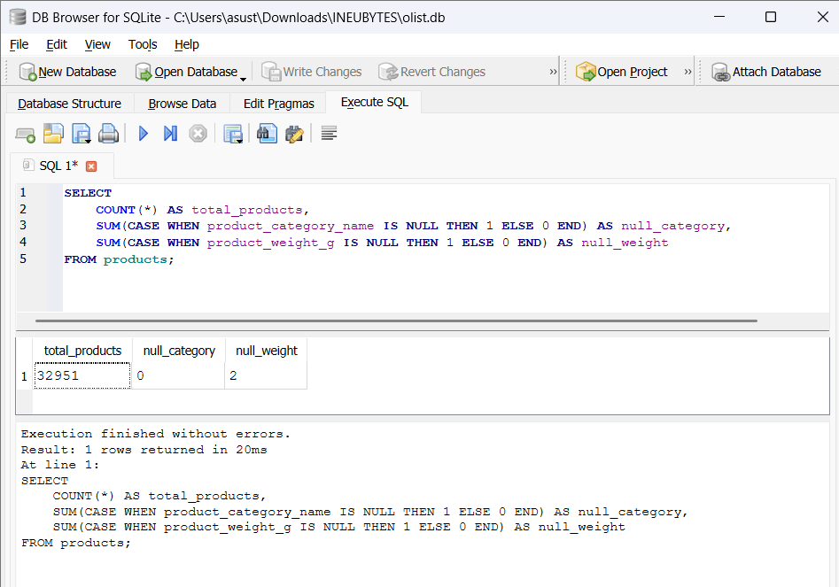
📸 2.5 Products with Missing Category
2.6 Review Comment Storage Format
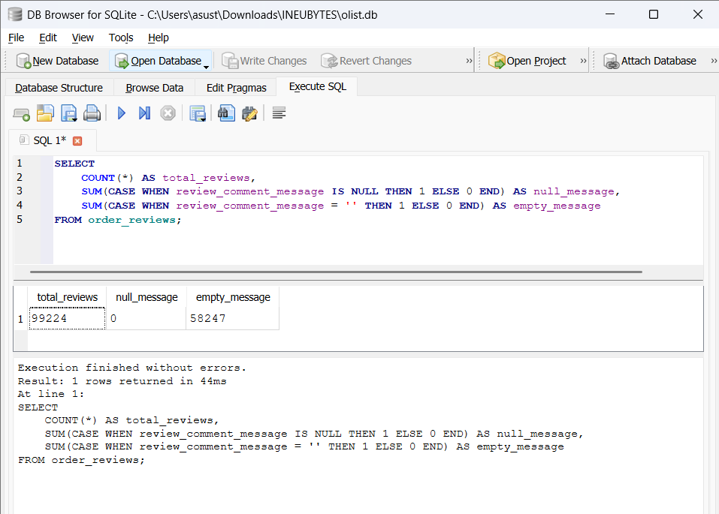
📸 2.6 Review Comment Storage Format
2.7 Deduplicated Geolocation View
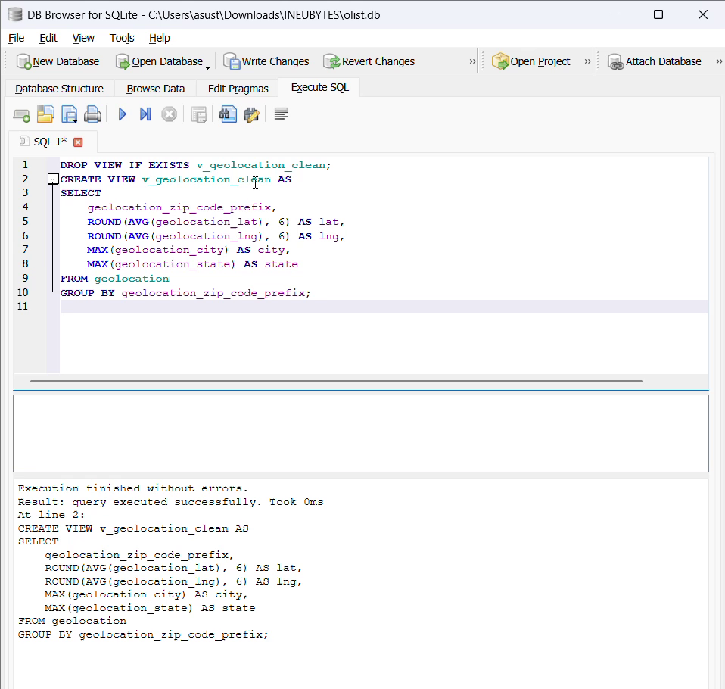
🎥 2.7 Deduplicated Geolocation View
▶️ Watch: https://drive.google.com/file/d/1GYogYe-_xEsJBFVKvWQtP3O7ZeZqcAvp/view?usp=drive_link

2.8 Clean Orders View
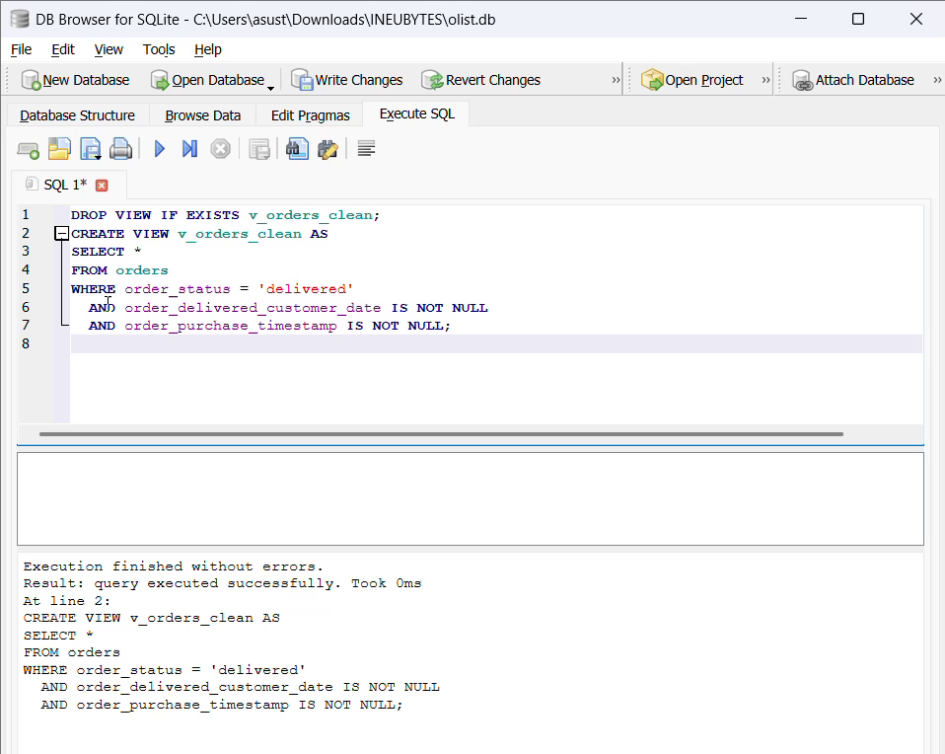
🎥 2.8 Clean Orders View
▶️ Watch: https://drive.google.com/file/d/1dkJBivgNtQi5zznGjKv_GRPBRGYX__uV/view?usp=drive_link

2.9 Category Name Casing
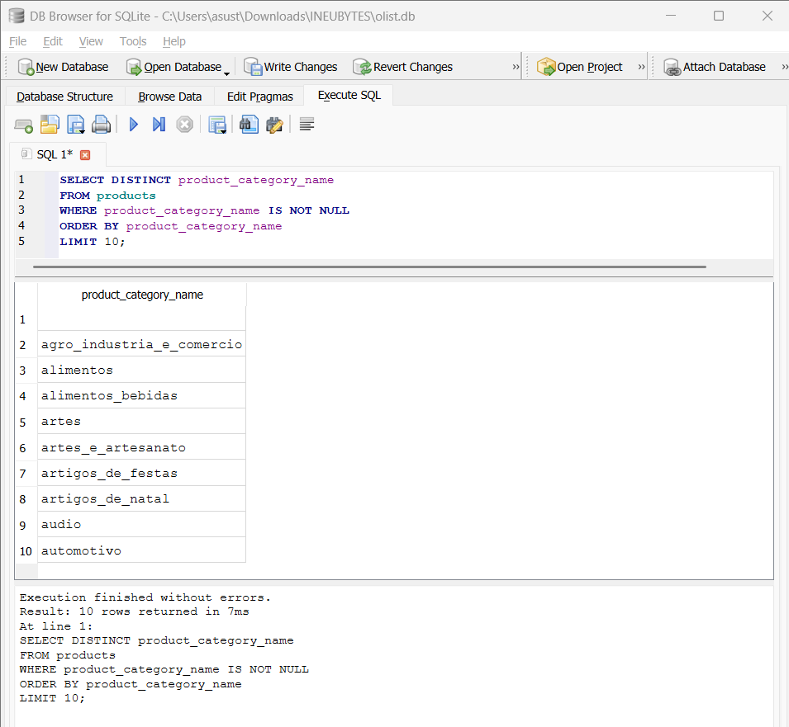
📸 2.9 Category Name Casing
2.10 Impossible Numeric Values
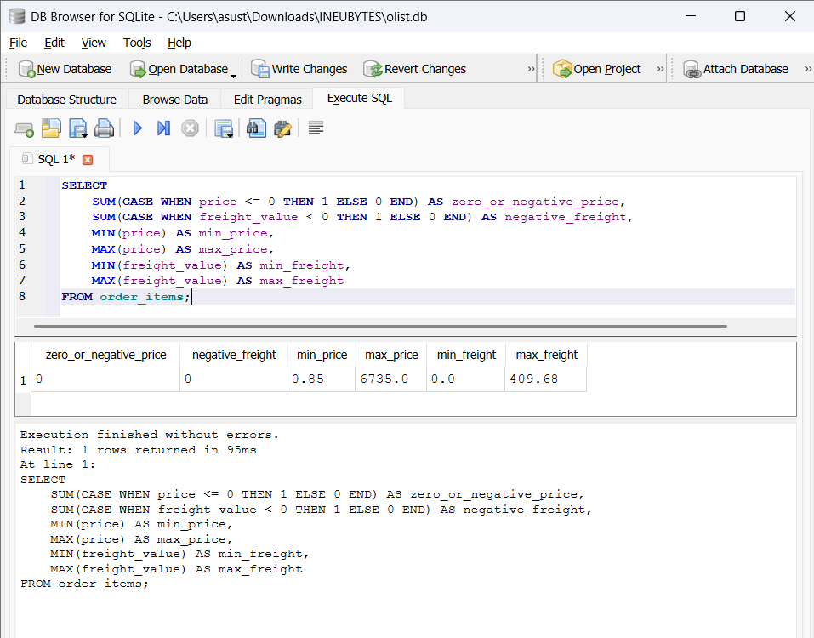
📸 2.10 Impossible Numeric Values
2.11 City Name Casing
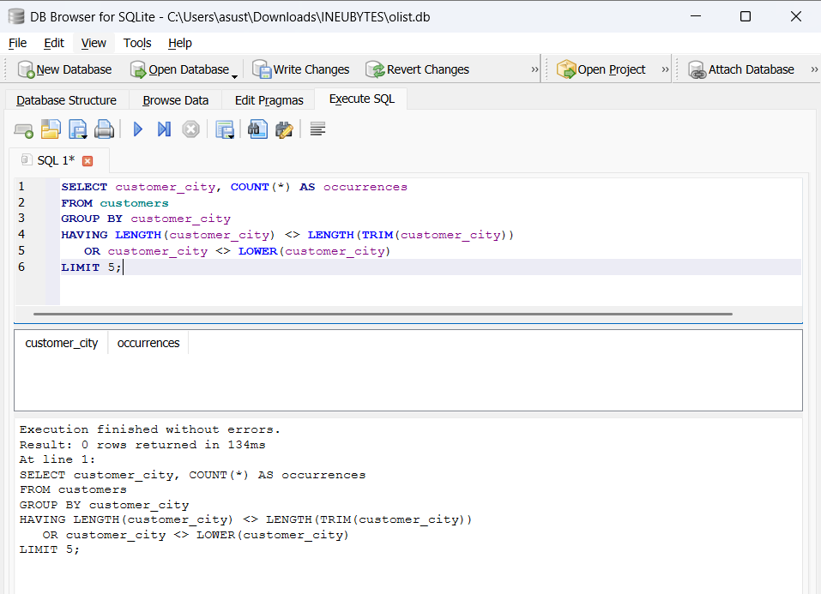
📸 2.11 City Name Casing

3. Business Analytics Queries (Q3.1 – Q3.20)
Q3.1: Total Revenue Analysis
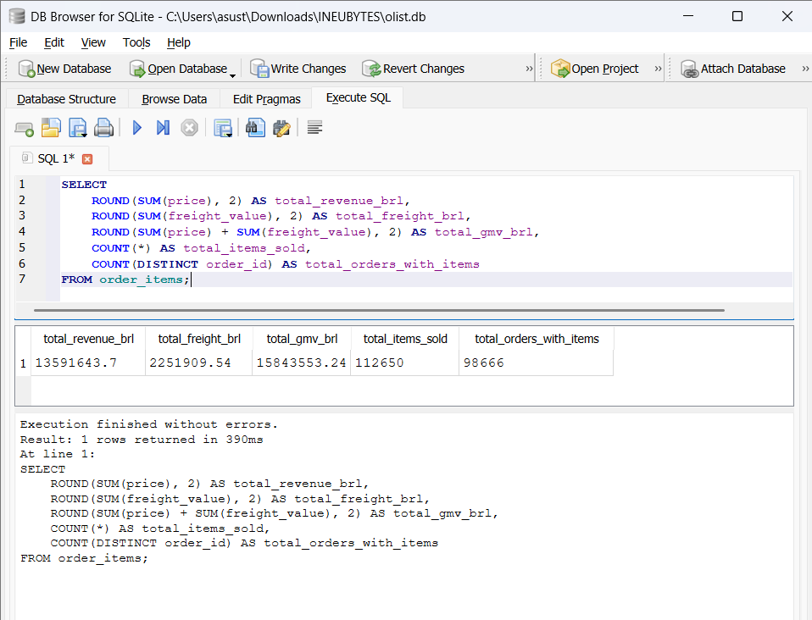
📸 Q3.1: Total Revenue Analysis

Q3.2: Average Order Value (AOV)
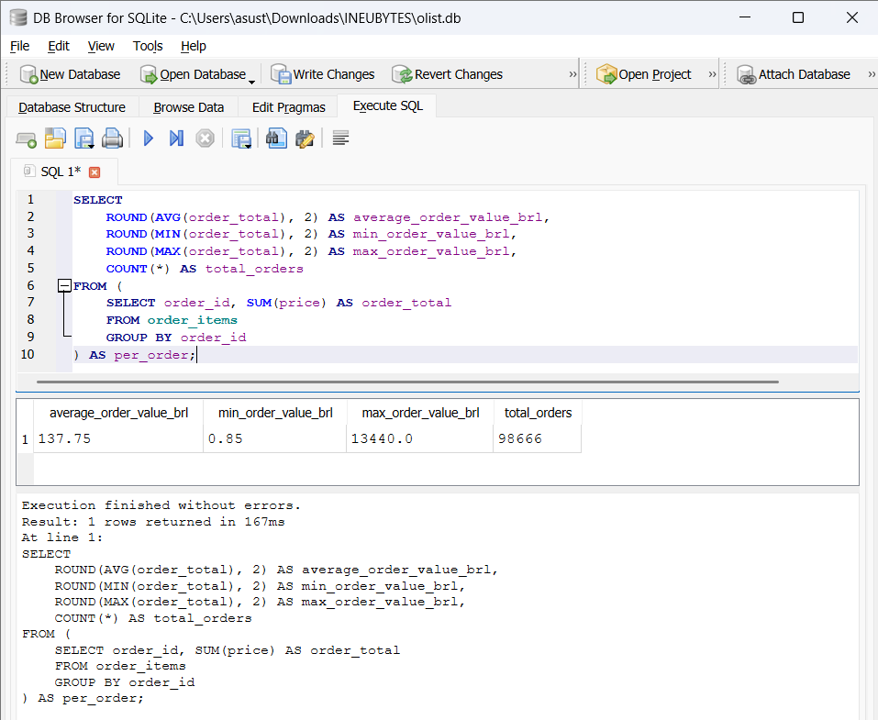
📸 Q3.2: Average Order Value (AOV)
Q3.3: Top 10 Product Categories by Revenue
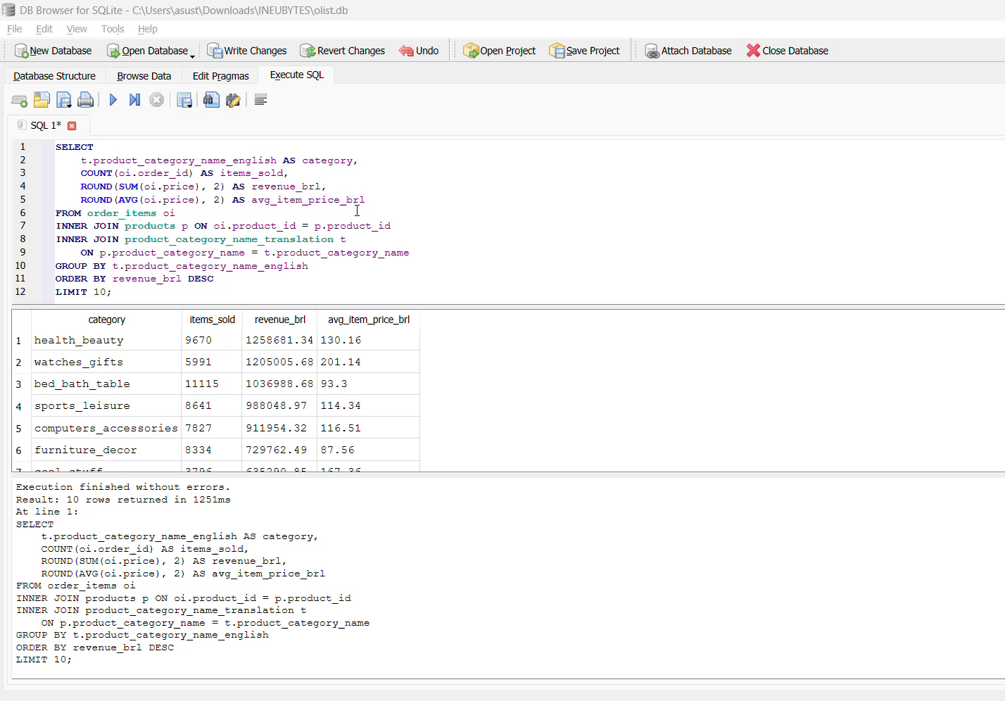
🎥 Q3.3: Top 10 Product Categories by Revenue
▶️ Watch: https://drive.google.com/file/d/1T_dCeO-f9bGoHQ_9QwXDXHRf8wcvYIRh/view?usp=drive_link
Q3.4: Revenue by Customer State
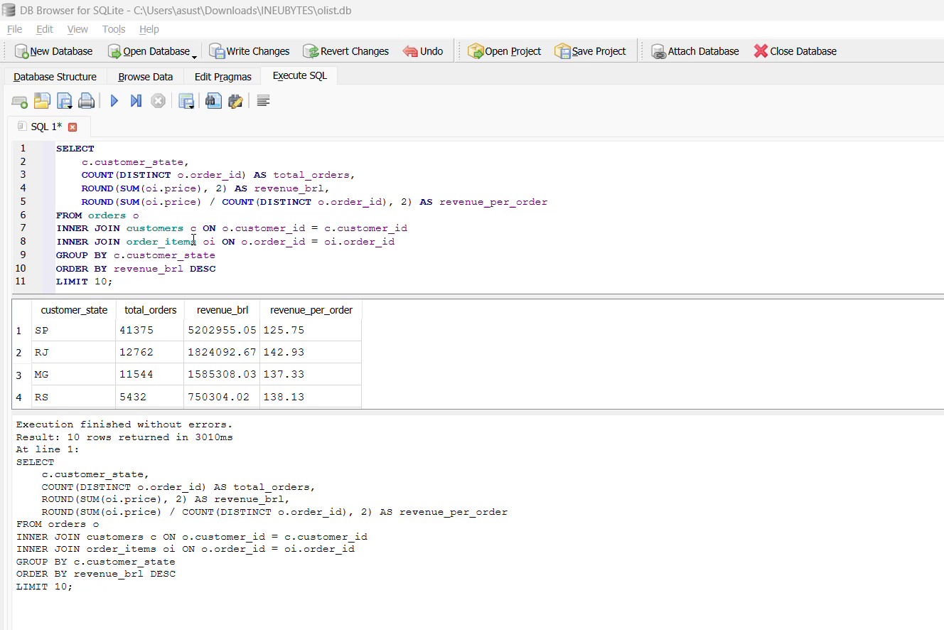
🎥 Q3.4: Revenue by Customer State
▶️ Watch: https://drive.google.com/file/d/1v9Iqiu8rEPDfg2obbescKMit80SgzjK3/view?usp=drive_link
Q3.5: Monthly Revenue Trend
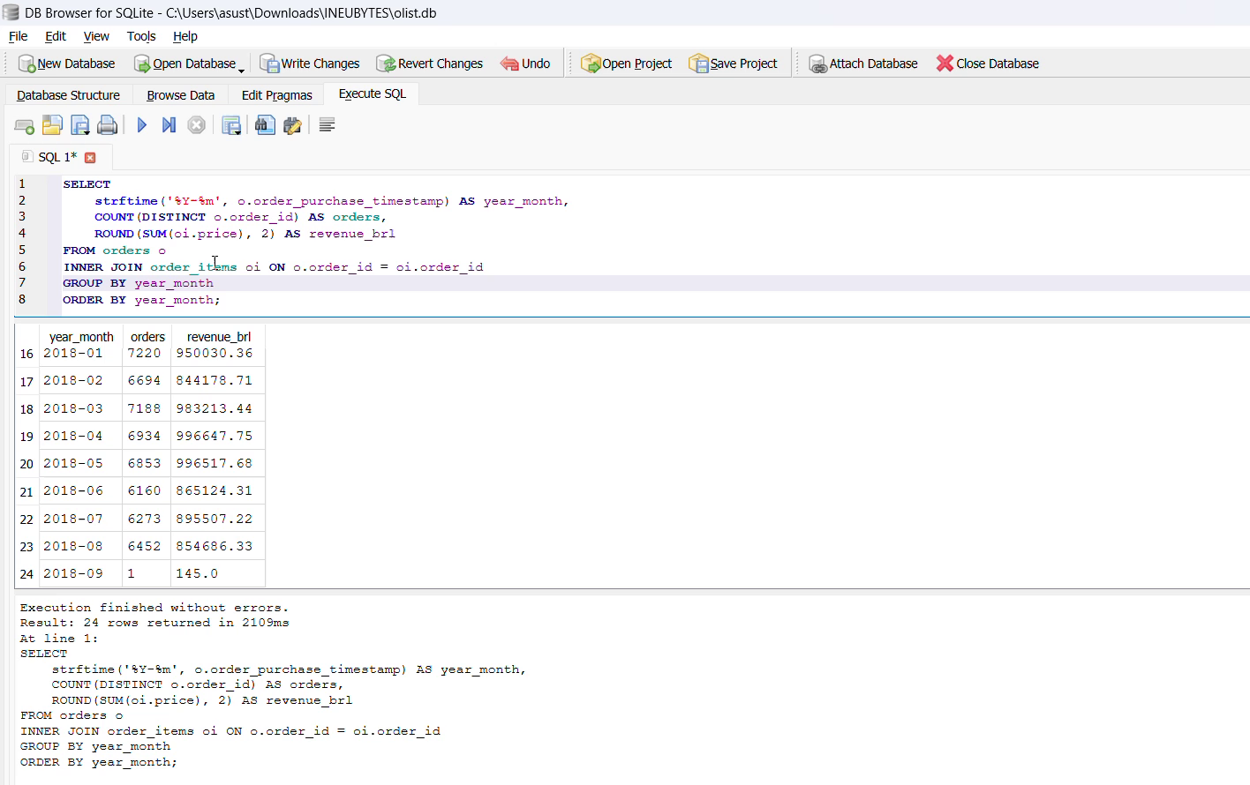
🎥 Q3.5: Monthly Revenue Trend
▶️ Watch: https://drive.google.com/file/d/1mKrlqyf15bBX26Pp3gWssQbuE6yyTAKt/view?usp=drive_link
Q3.6: Payment Method Distribution
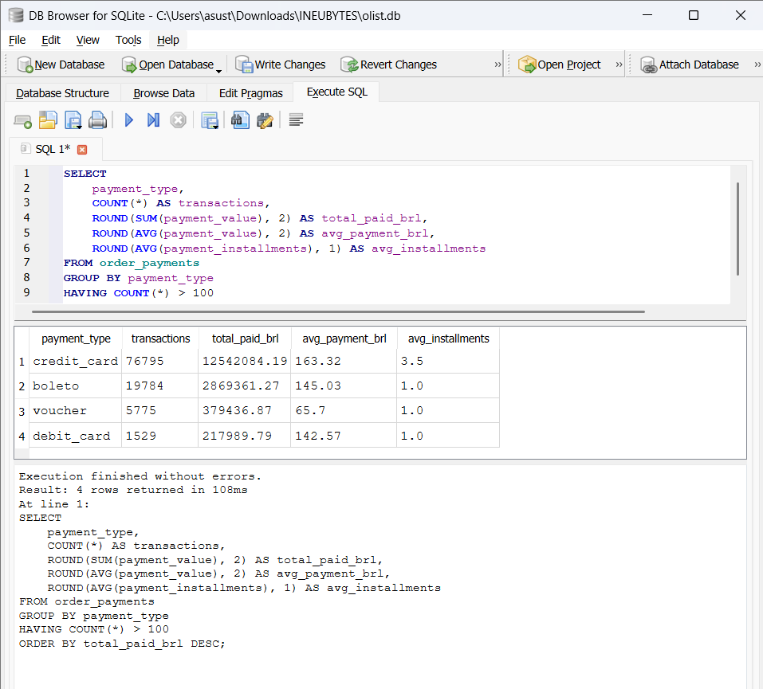
📸 Q3.6: Payment Method Distribution

Q3.7: Average Review Score by Category
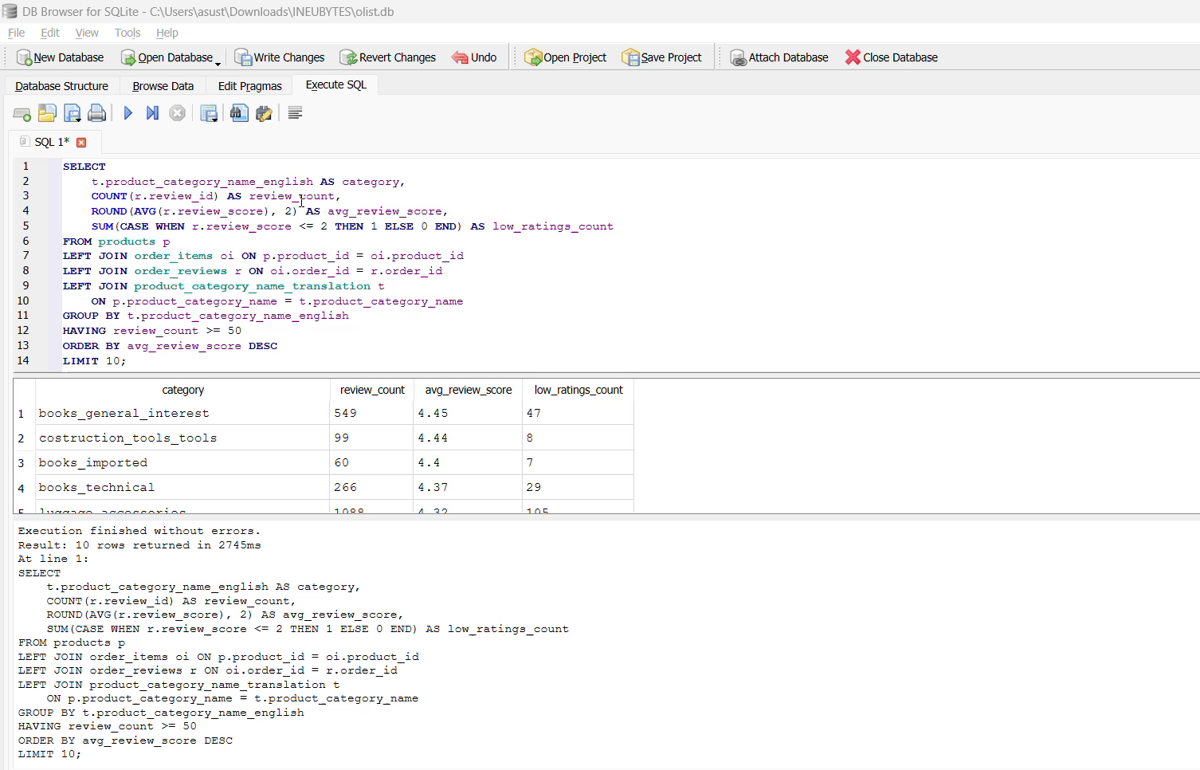
🎥 Q3.7: Average Review Score by Category
▶️ Watch: https://drive.google.com/file/d/1wwK0rFmaEED37nNm-OHsGq5MmxvM2vXS/view?usp=drive_link

Q3.8: Top 10 Sellers by Revenue (RANK)
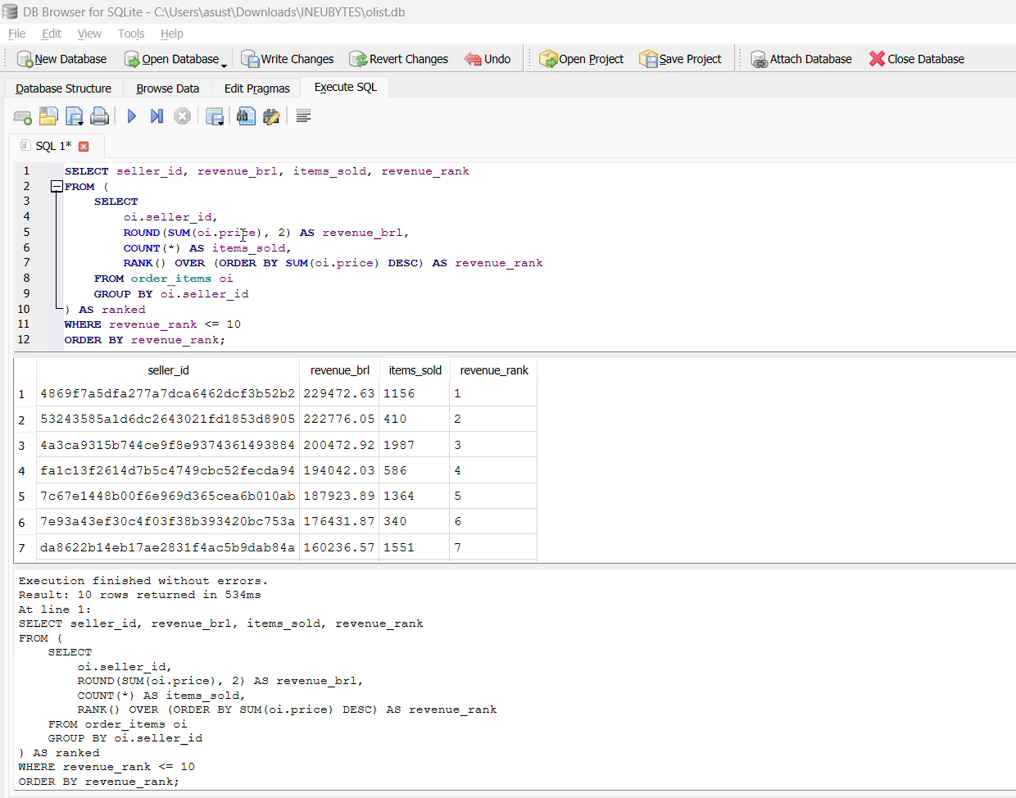
🎥 Q3.8: Top 10 Sellers by Revenue (RANK)
▶️ Watch: https://drive.google.com/file/d/1aP8g9niQ_pAPdYJqTZccEJPVaqVkDYRN/view?usp=drive_link

Q3.9: Cumulative Revenue (SUM OVER)
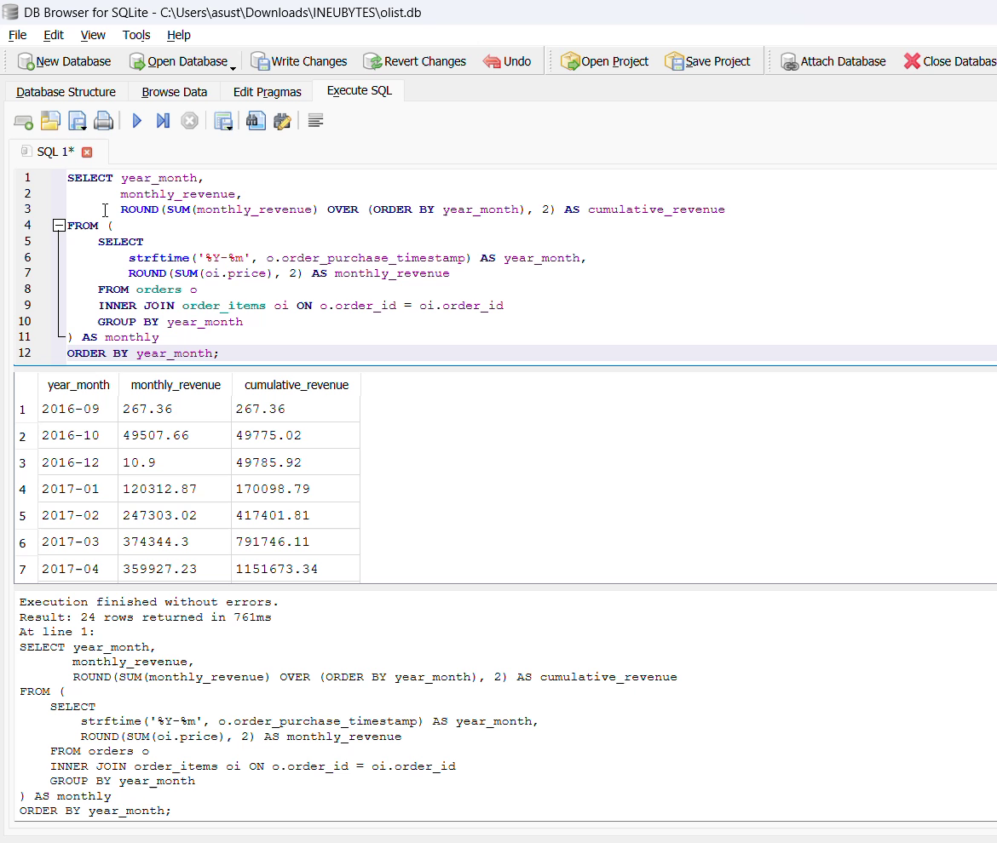
🎥 Q3.9: Cumulative Revenue (SUM OVER)
▶️ Watch: https://drive.google.com/file/d/1pzAlryaziU49sdIp5UApv3CStrk-MkkM/view?usp=drive_link

Q3.10: Month-over-Month Growth (LAG)
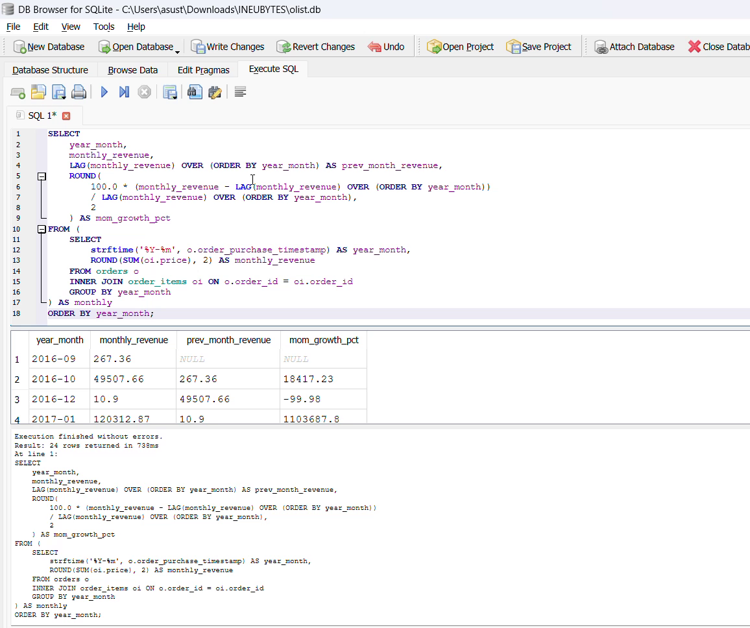
🎥 Q3.10: Month-over-Month Growth (LAG)
▶️ Watch: https://drive.google.com/file/d/1vTwh0FDqpT9MPHnQ6v3wqH2AKbK668ws/view?usp=drive_link

Q3.11: Average Delivery Time
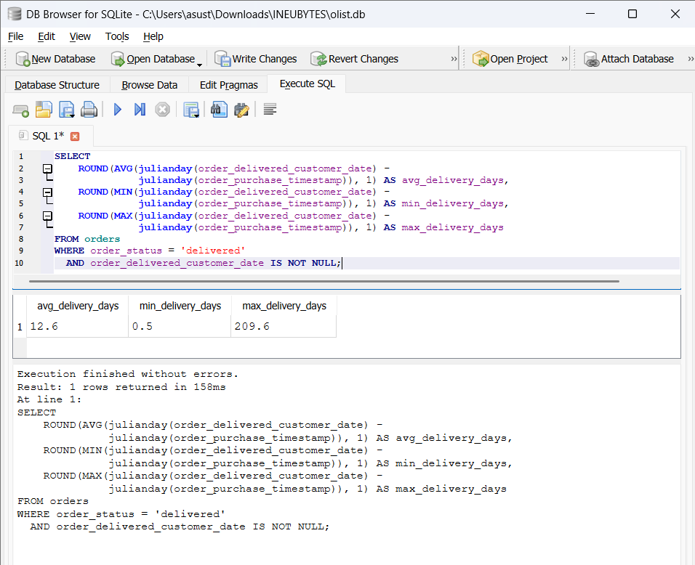
📸 Q3.11: Average Delivery Time
Q3.12: On-Time vs Late Delivery Rate
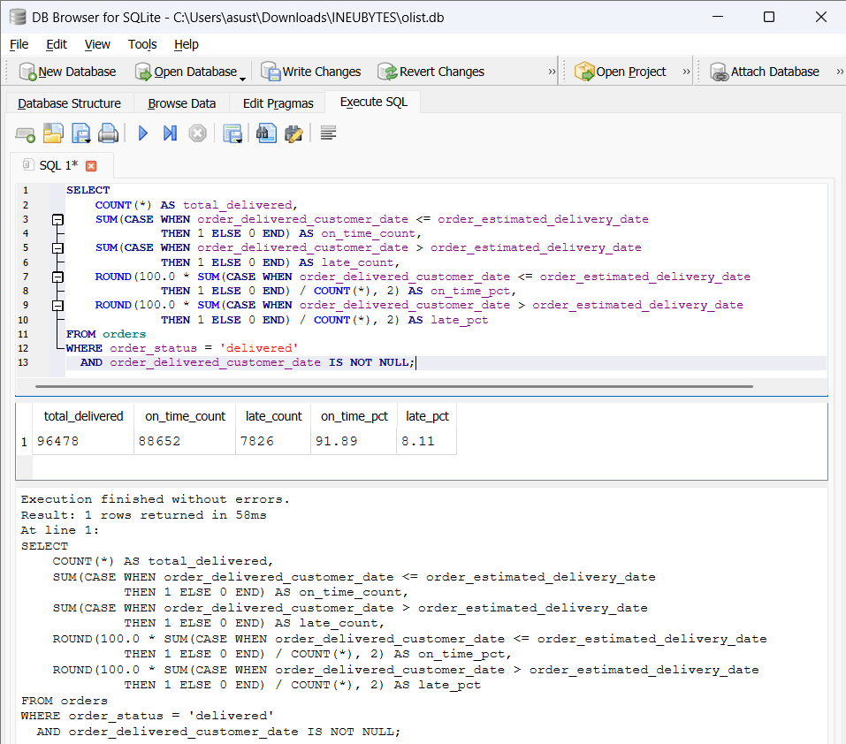
📸 Q3.12: On-Time vs Late Delivery Rate
Q3.13: Repeat Customers (Self-Join)
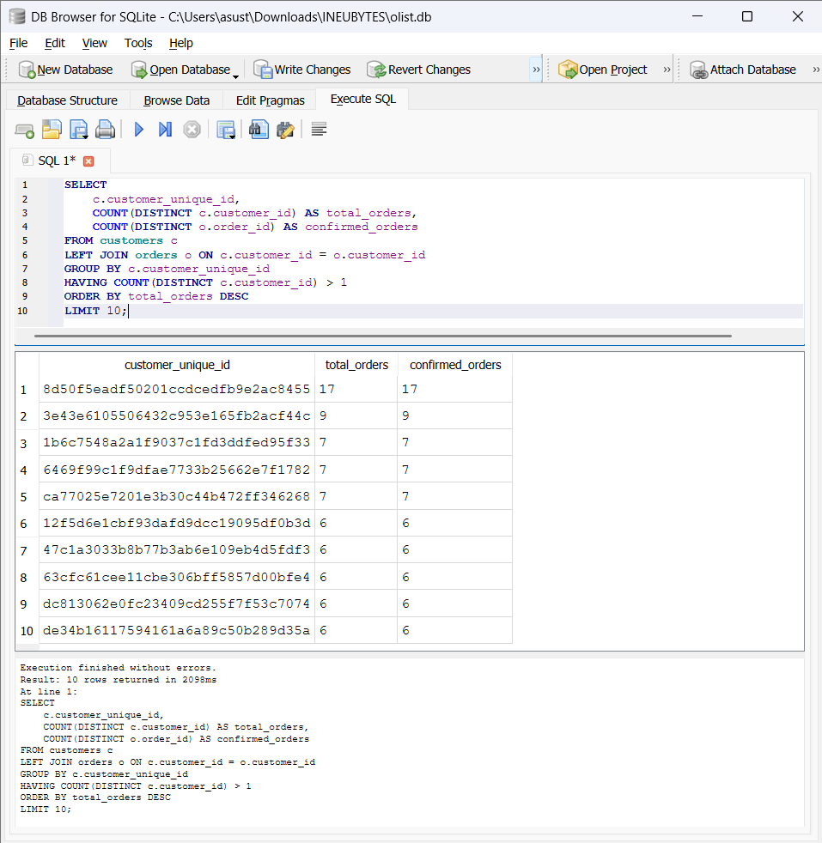
📸 Q3.13: Repeat Customers (Self-Join)

Q3.14: Review Score Distribution
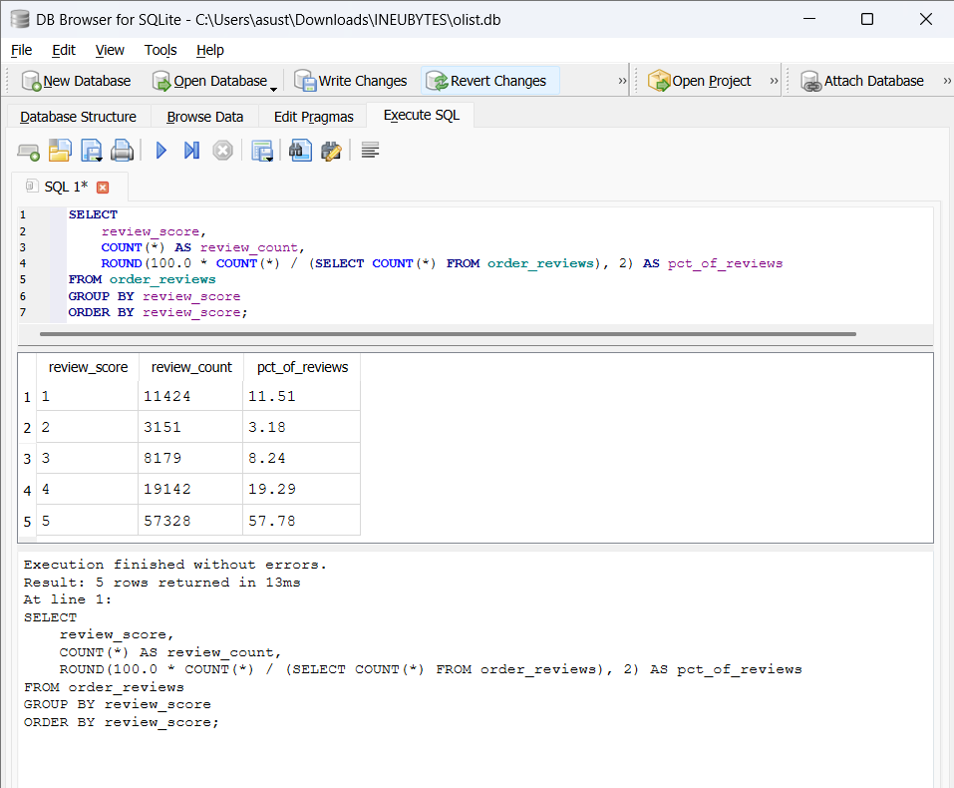
📸 Q3.14: Review Score Distribution

Q3.15: Review Score vs Delivery Time
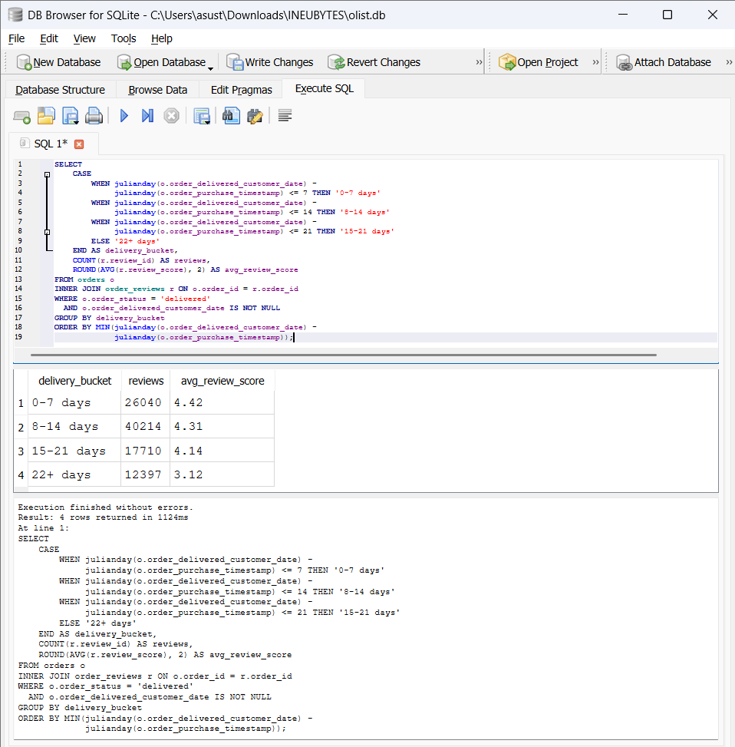
📸 Q3.15: Review Score vs Delivery Time

Q3.16: Top 5 Cities by Revenue
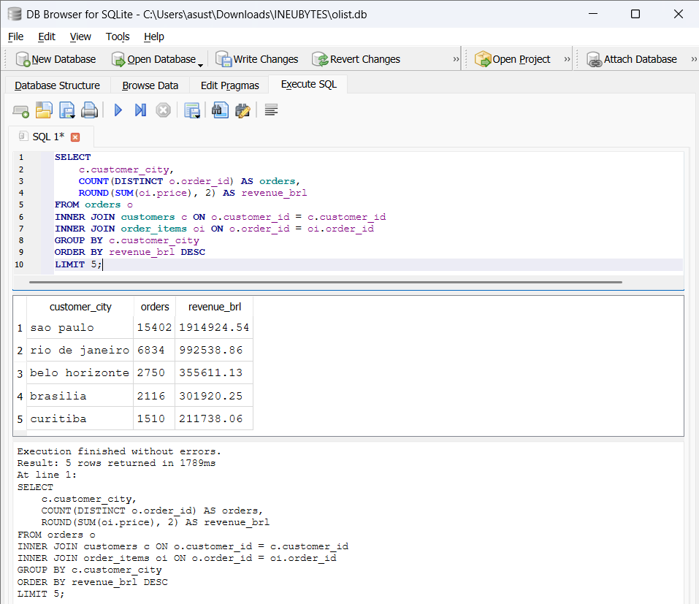
📸 Q3.16: Top 5 Cities by Revenue
Q3.17: Products Never Sold (Anti-Join)
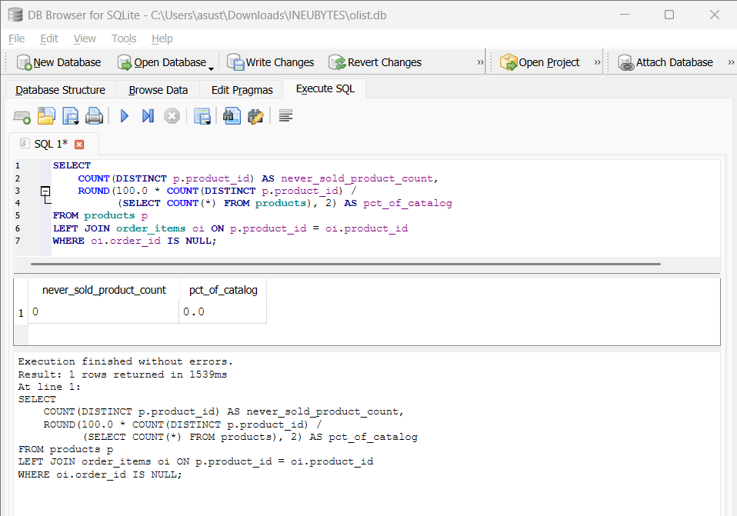
📸 Q3.17: Products Never Sold (Anti-Join)
Q3.18: Revenue Concentration (NTILE)
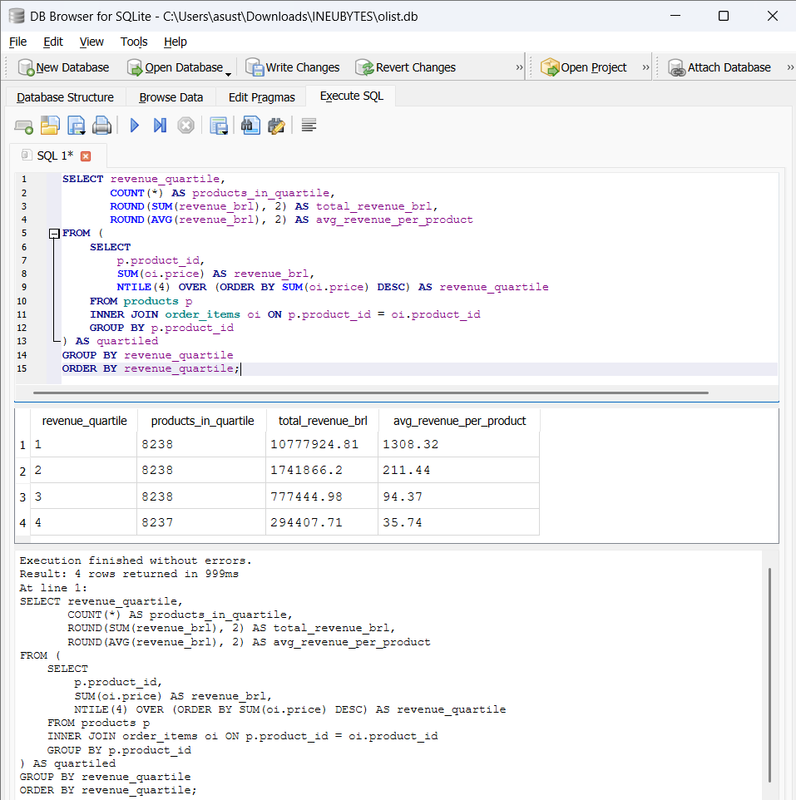
📸 Q3.18: Revenue Concentration (NTILE)

Q3.19: Payment Installments Distribution
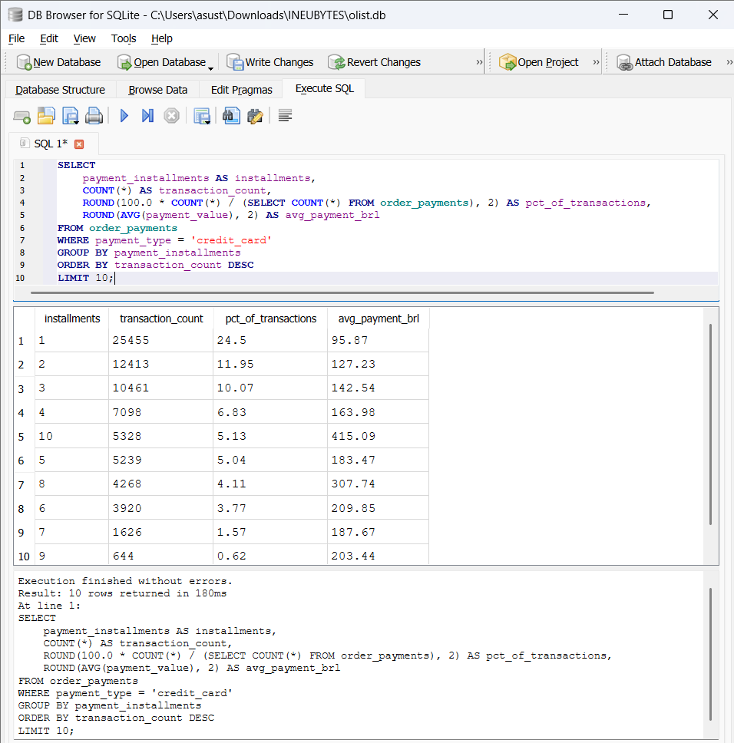
📸 Q3.19: Payment Installments Distribution

Q3.20: Freight Ratio by Product Weight
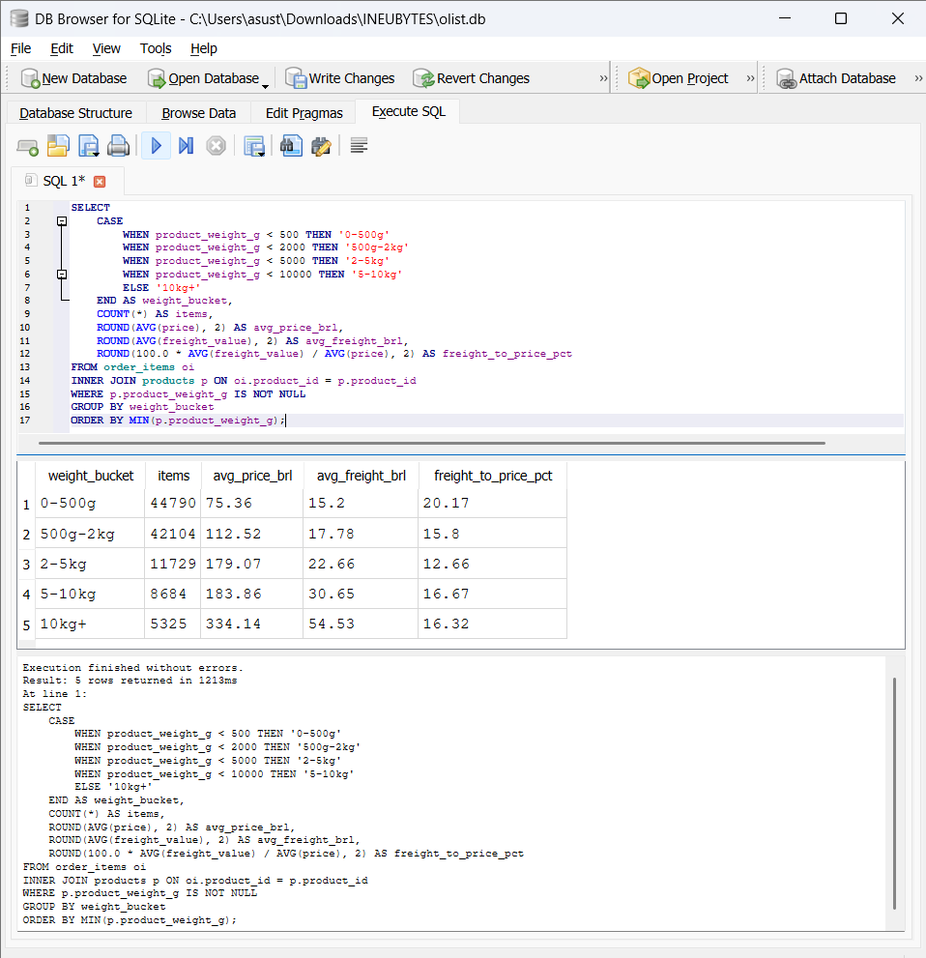
📸 Q3.20: Freight Ratio by Product Weight

4. KPIs & Cohort Analysis
4.1 Six Core Business KPIs
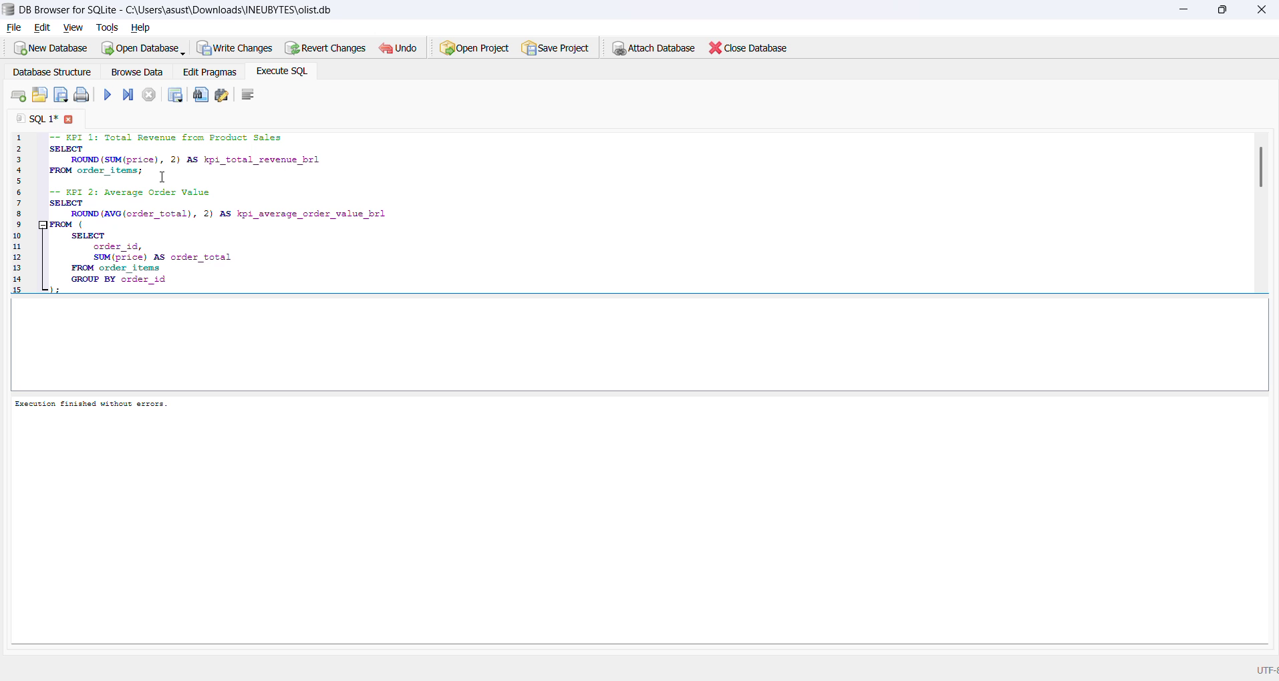
🎥 Query 4.1 — All 6 KPIs computed in a single SQL query
▶️ Watch: https://drive.google.com/file/d/1LyzsHpUPQNMuRwn0PVBtioyukK7YFl4z/view?usp=drive_link
KPI | Value
Total Revenue | R$ 13,591,643.70
Avg Order Value | R$ 137.75
Total Orders | 96,478
Unique Customers | 96,096
Repeat Purchase Rate | 3.12%
Avg Review Score | 4.09 / 5.0

4.2 Monthly KPI Trend Table
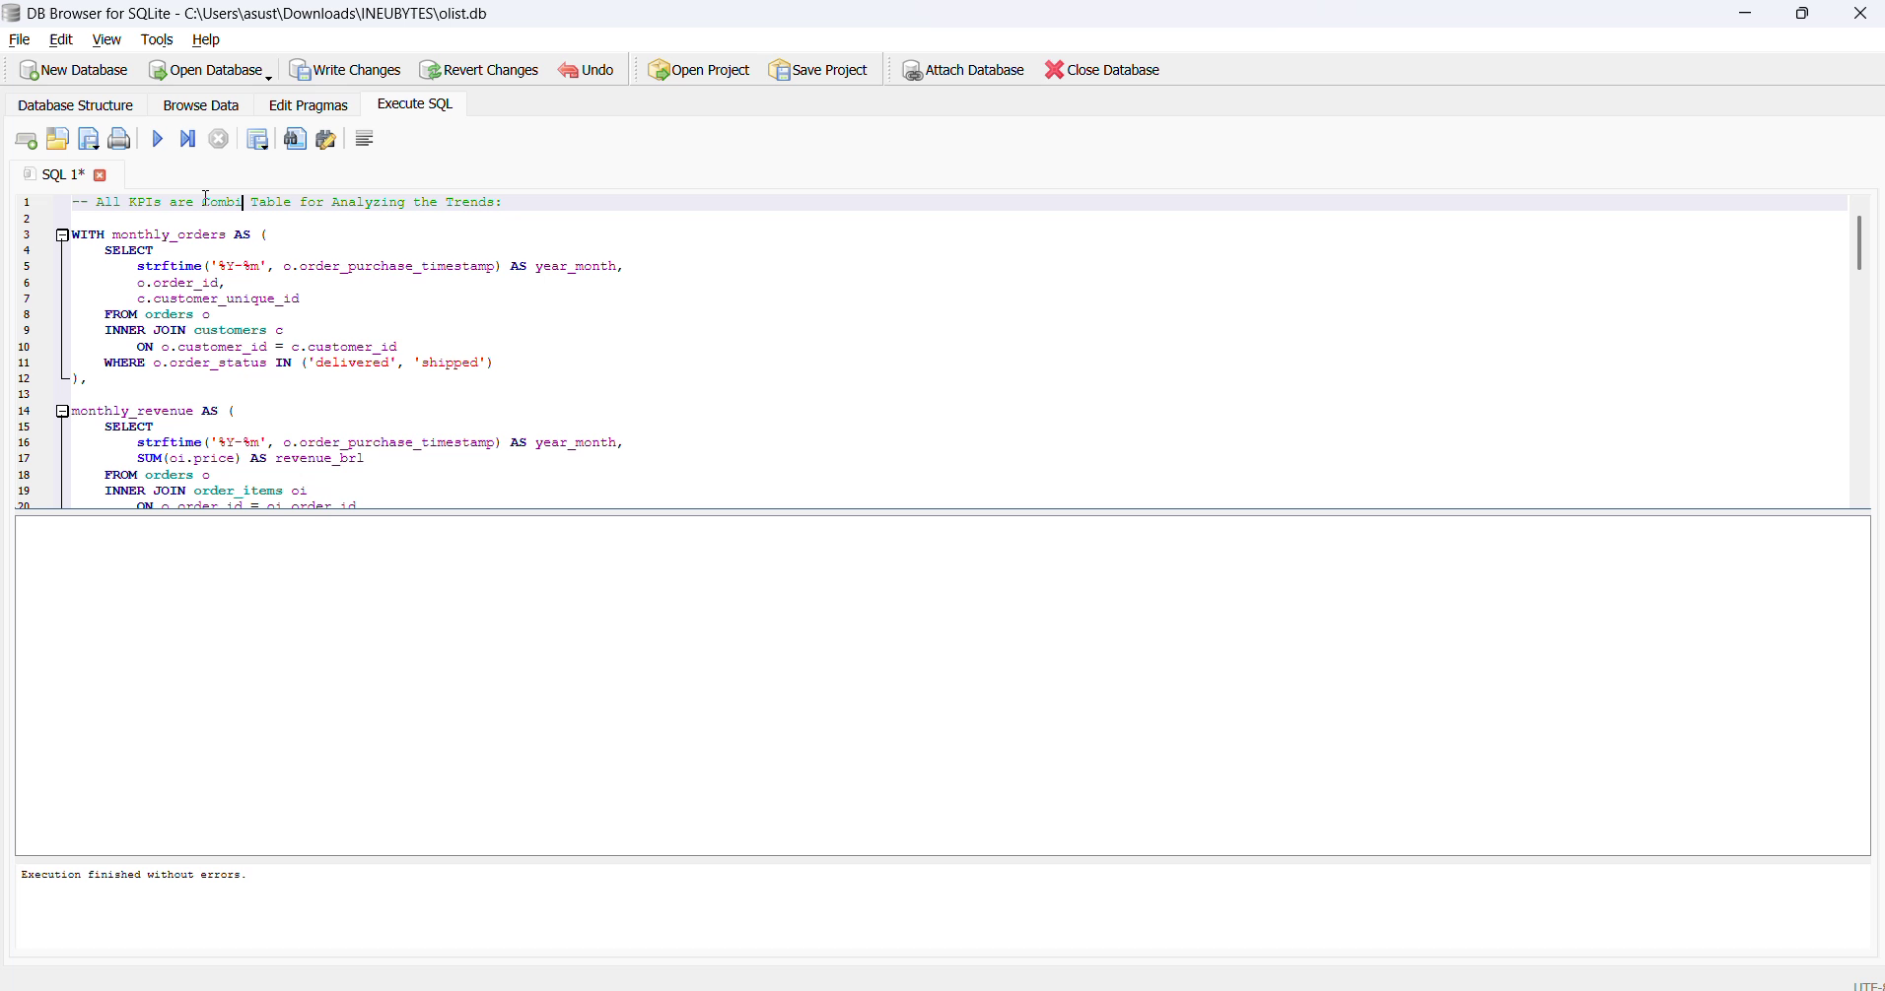
🎥 Query 4.2 — Monthly KPI trends using CTEs
▶️ Watch: https://drive.google.com/file/d/1bbzuDewHLH6-GaoPlV3AyZiyNTGSNPUG/view?usp=drive_link
4.3 Cohort Analysis — Customer Retention
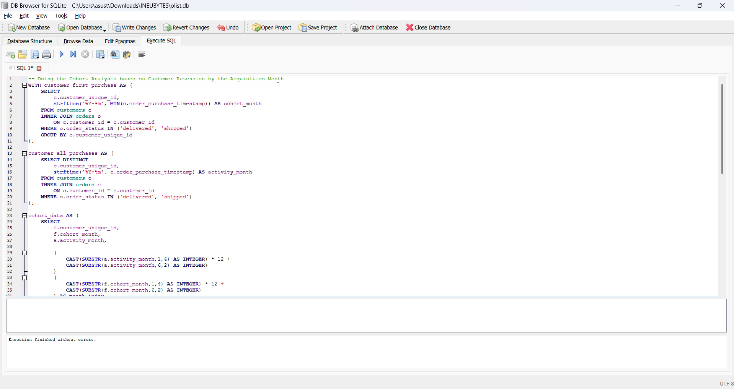
🎥 Query 4.3 — Detailed cohort retention data
▶️ Watch: https://drive.google.com/file/d/1bIU_ihwPMLbJQsM33LJSPYAQYB87FryD/view?usp=drive_link
4.4 Cohort Retention Pivot Table (M0–M6)
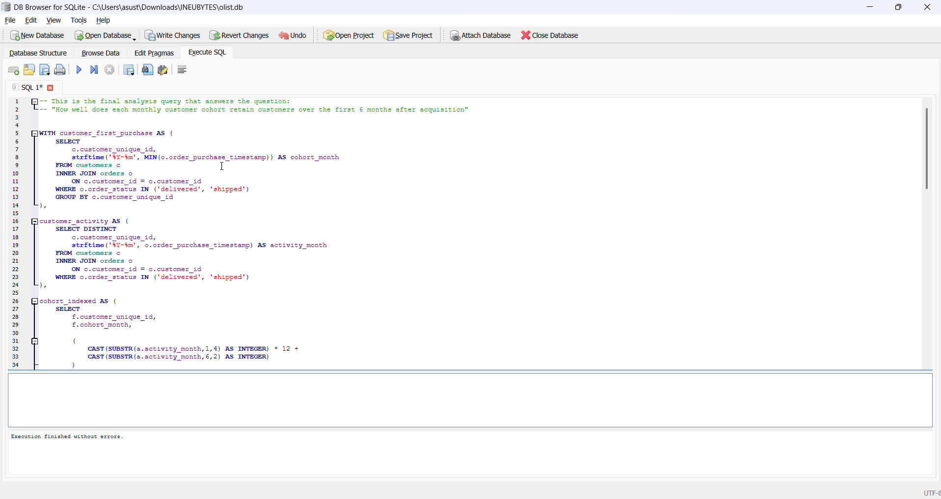
🎥 Query 4.4 — Cohort retention pivot table
▶️ Watch: https://drive.google.com/file/d/1zFQG2-Cr64ofp95URCv6YCO4eXrtUBI3/view?usp=drive_link
5. Reporting Summary
- Total revenue: R$13.59M, 96,478 orders, AOV R$137.75
- SP = 38.28% of revenue; top 3 states = 63%
- Revenue peaks Nov 2017 (Black Friday) at R$1.01M
- Credit card = 78.3% of payment value
- 91.89% on-time delivery, 12.6 day average
- 3.12% repeat purchase rate — one-time-purchase marketplace
- 57.78% give 5★, 11.51% give 1★ (bimodal)
- Faster delivery is strongly associated with higher reviews (4.42★ vs 3.12★)
- Top 25% product categories generate 79.3% of revenue (Pareto)
- 33.15% of credit card payments are 1-installment

